

**Nombre Completo: Univ. Ricardo David La Madrid Alarcon**

**Asignatura: Sistemas Móviles y Embebidos**

**Carrera: INGENIERÍA DE SISTEMAS**

**Paralelo: SOM (1)**

**Docente: Lic. William R. Barra Paredes**

**fecha: 06/05/020**

|  |
| --- |
| **APP - CALCULADORA. (Hito3TareaFinal)** |
| Debe de crear una calculadora científica capaz de resolver operaciones matemáticas fundamentales, tales como SUMA, RESTA, MULTIPLICACION y DIVISION adicionalmente debe de obtener resultados como COS, SEN, x2, etc. Debe basar su solución de acuerdo al siguiente diseño. |

|  |
| --- |
|  |

**Onboarding capturas**

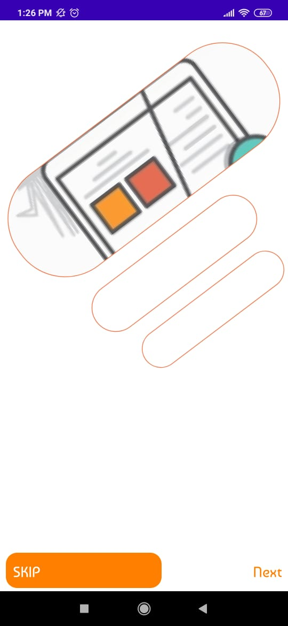

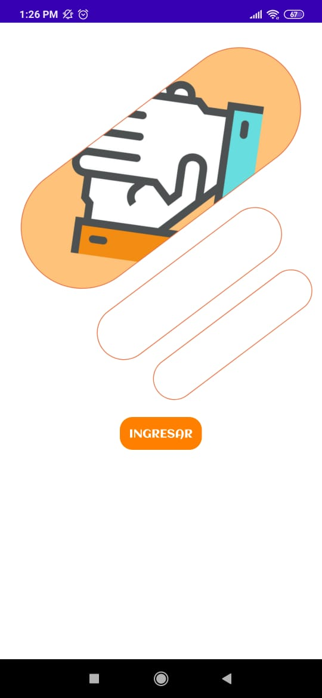

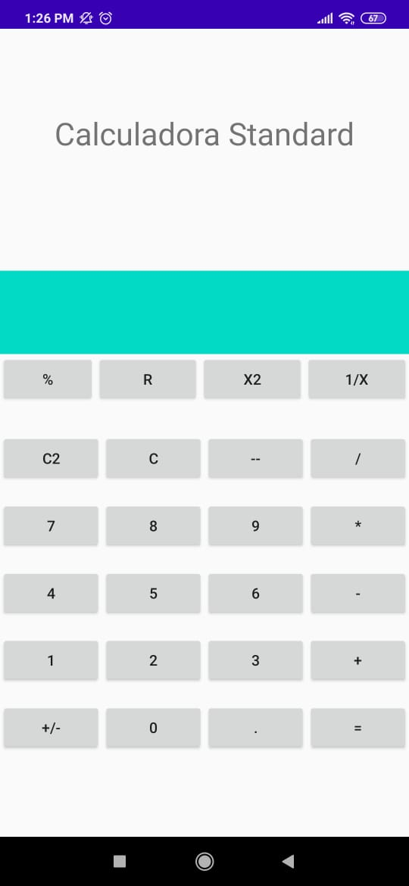

Fragment1.Java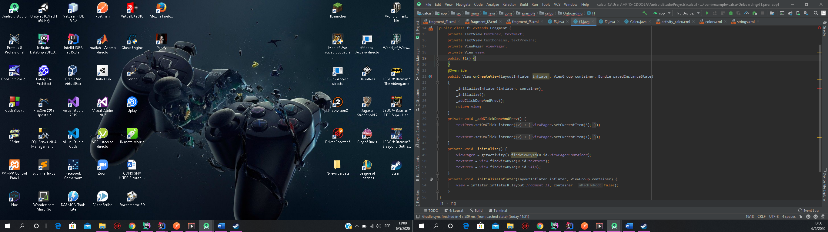

Fragment1.xml

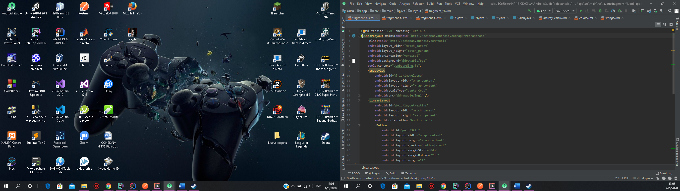

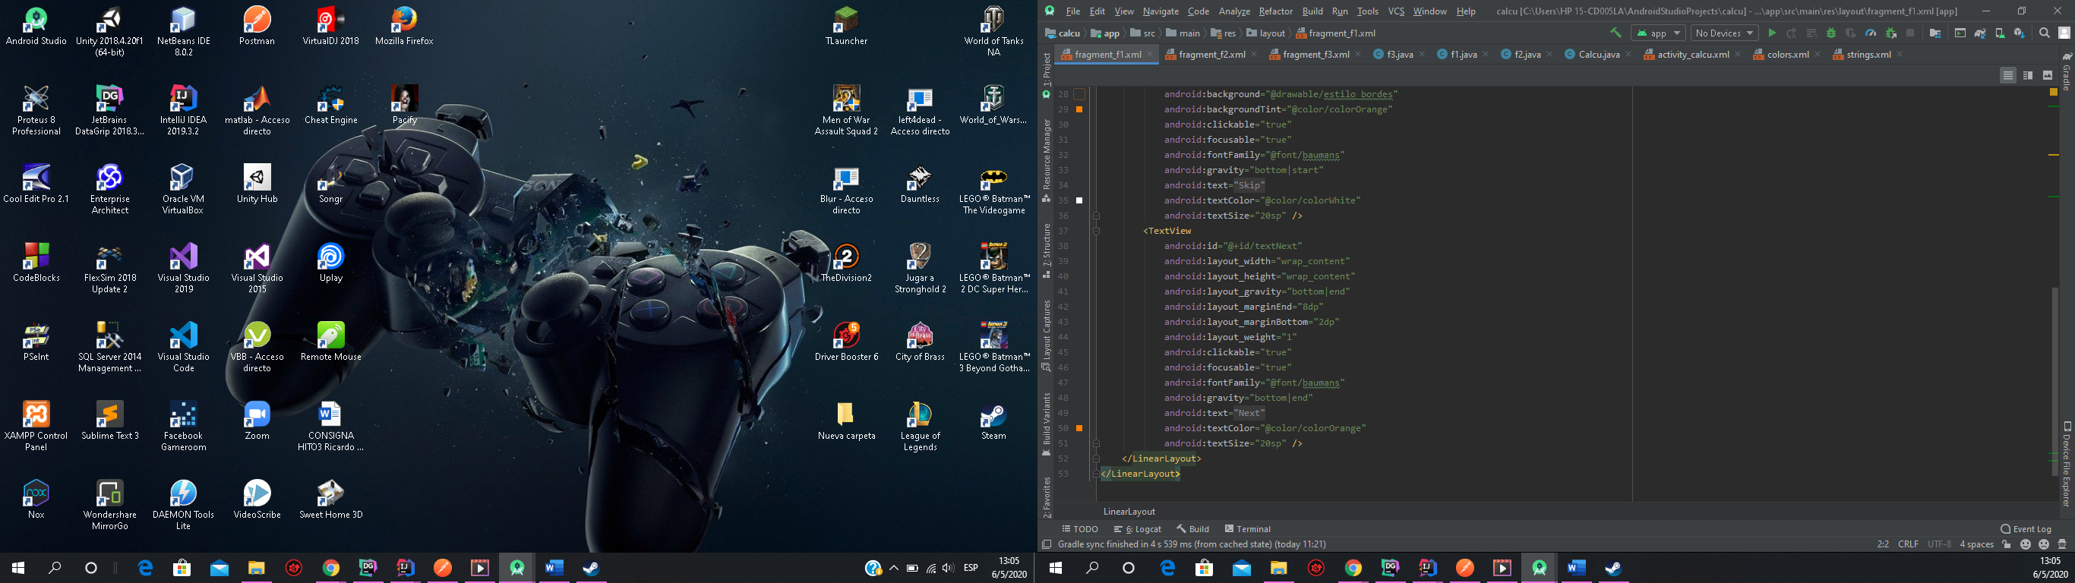

Fragment2.Java

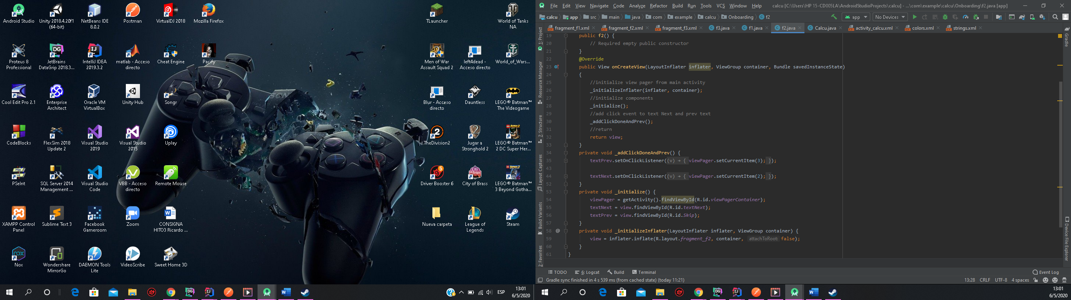

Fragment2.xml

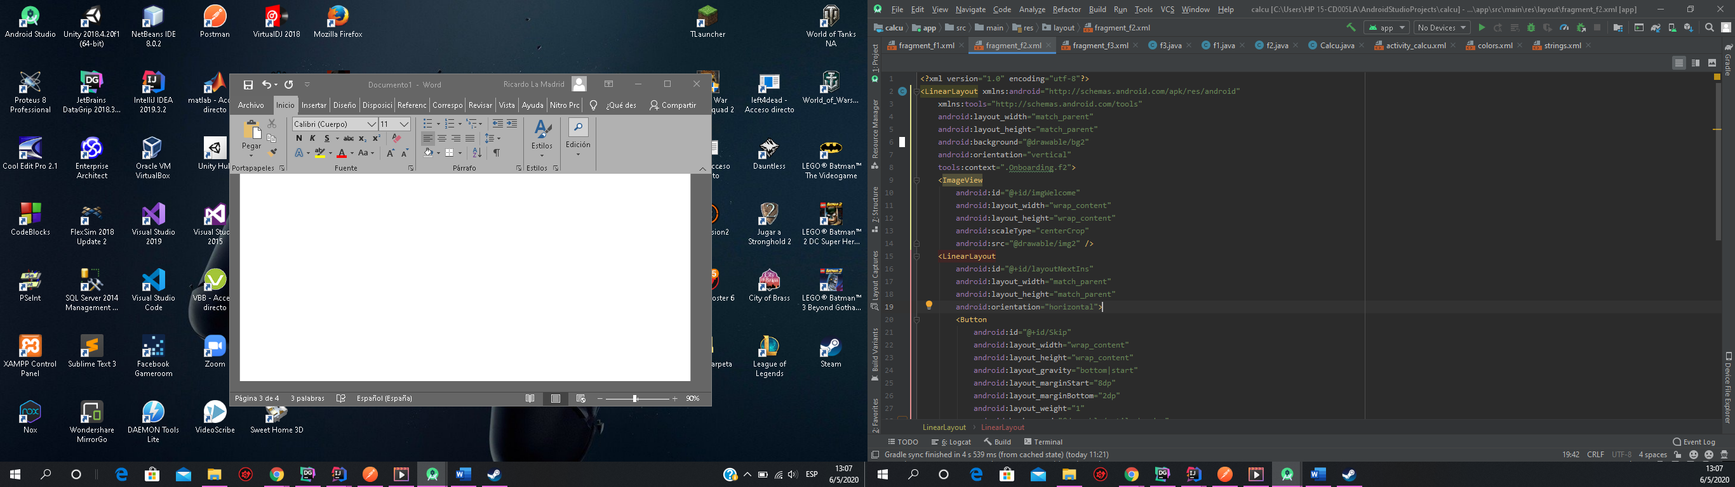

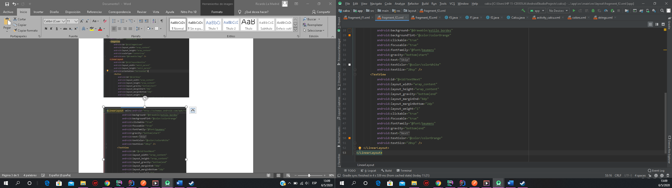

Fragment3.java

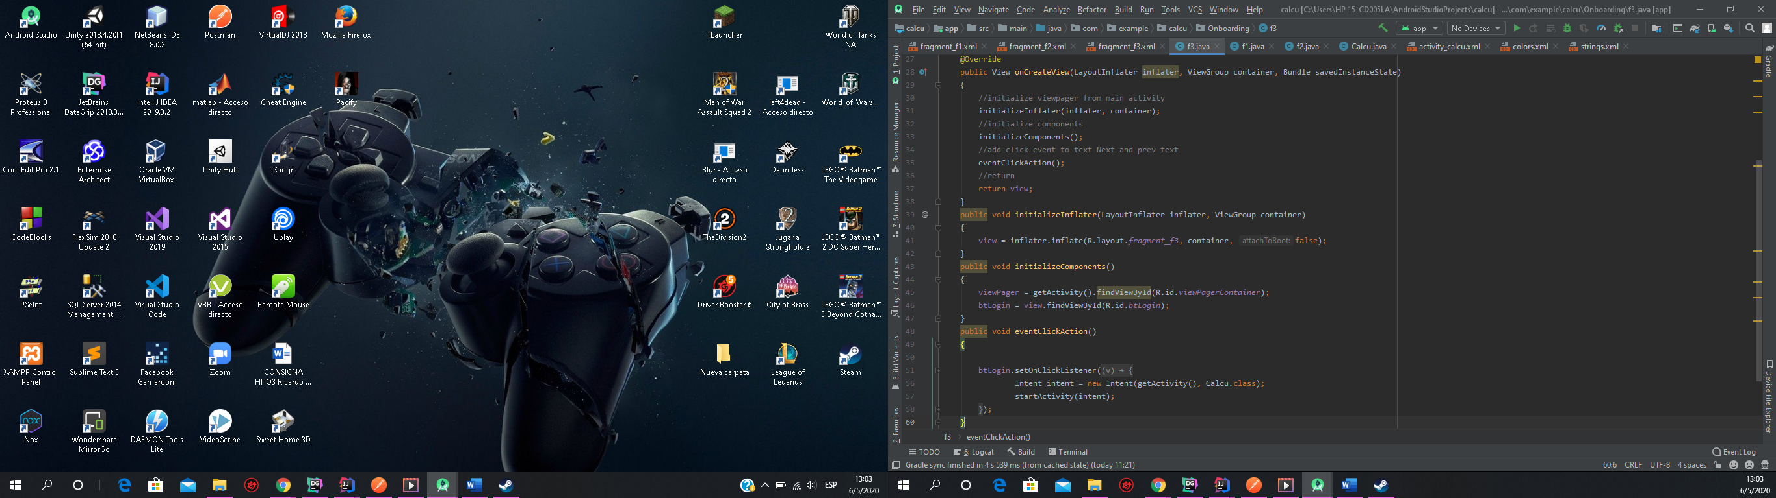

Fragment3.xml

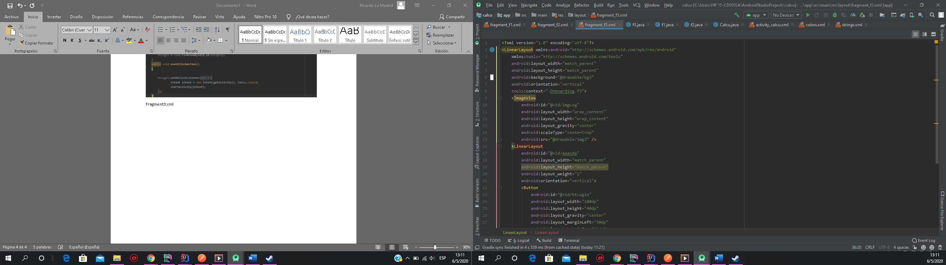

Calcu.java

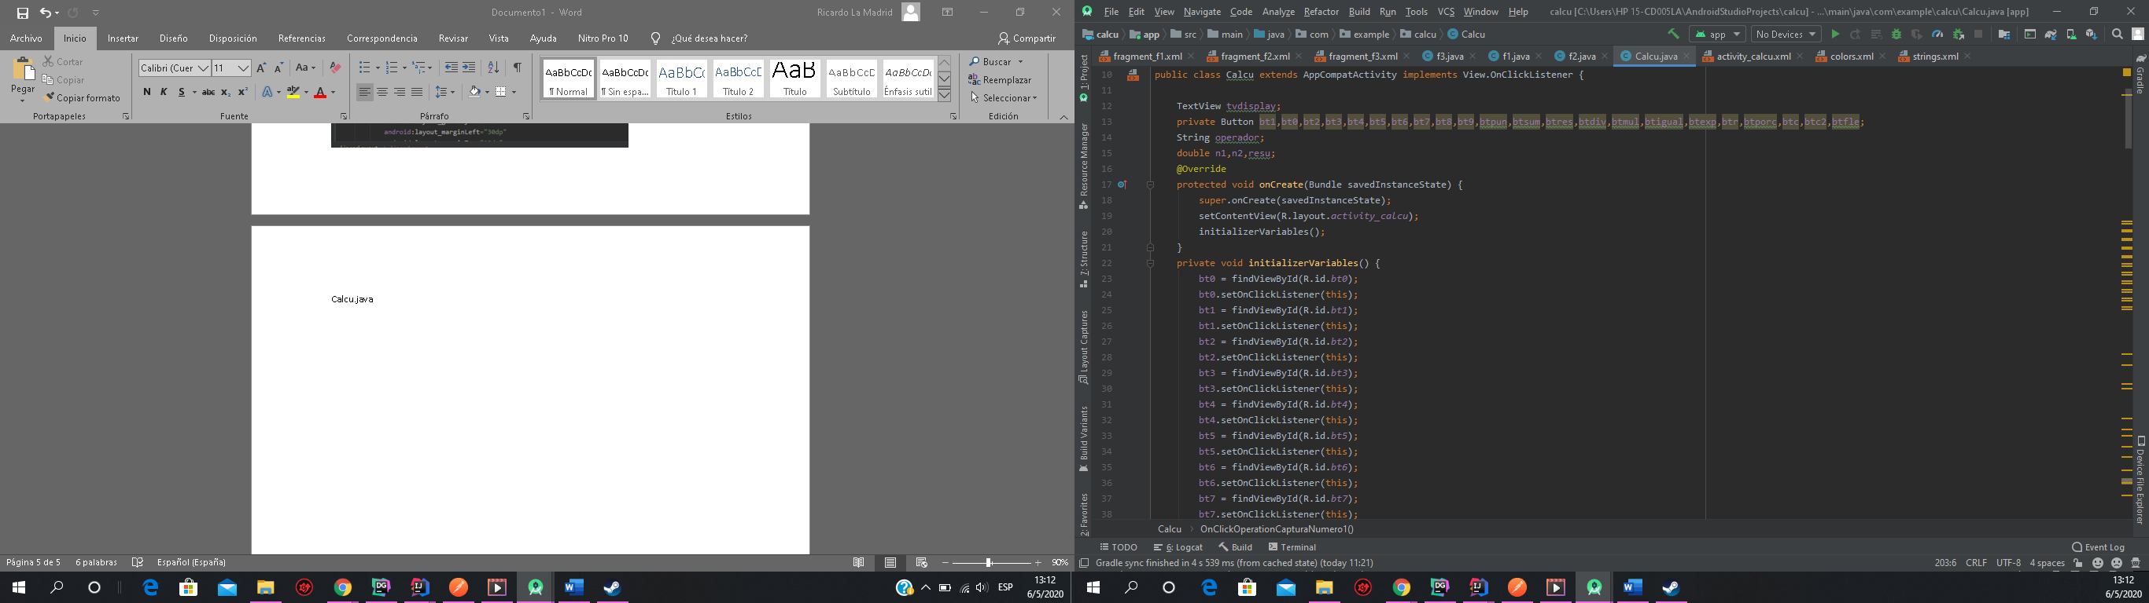

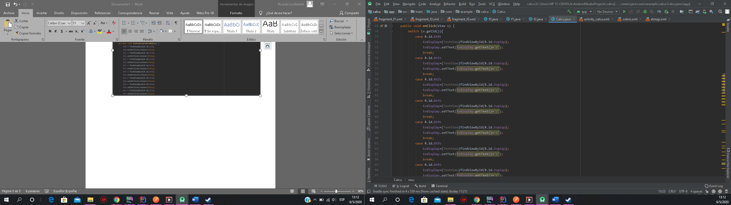

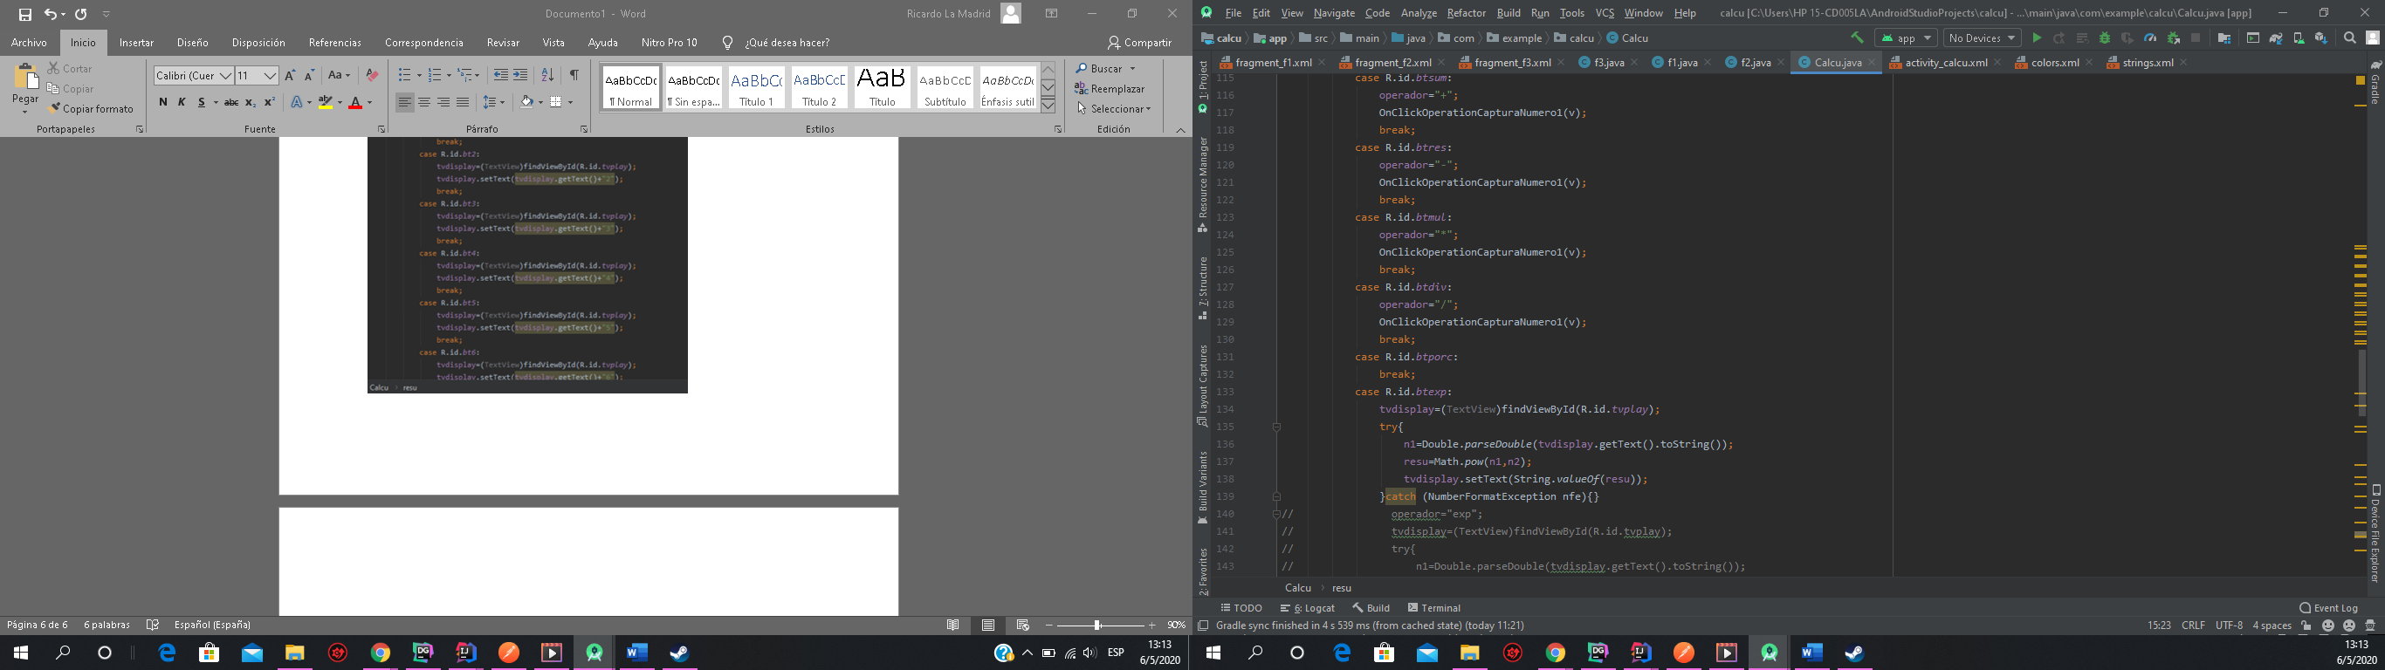

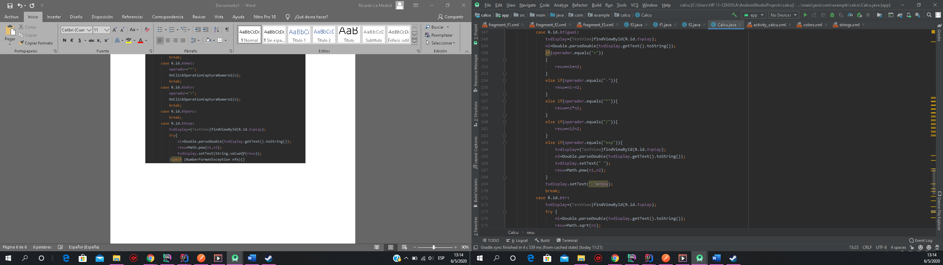

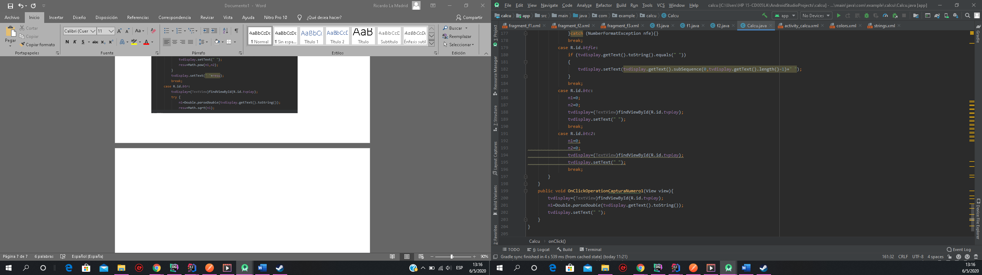

Calcu.xml

<?xml version="1.0" encoding="utf-8"?>  
<LinearLayout xmlns:android="http://schemas.android.com/apk/res/android"  
 xmlns:app="http://schemas.android.com/apk/res-auto"  
 xmlns:tools="http://schemas.android.com/tools"  
 android:layout_width="match_parent"  
 android:layout_height="match_parent"  
 android:orientation="vertical"  
 tools:context=".Calcu">  
 <LinearLayout  
 android:layout_width="match_parent"  
 android:layout_height="match_parent"  
 android:layout_weight="1"  
 android:orientation="vertical">  
 <TextView  
 android:id="@+id/textView"  
 android:layout_width="wrap_content"  
 android:layout_height="wrap_content"  
 android:layout_gravity="center"  
 android:layout_marginTop="80dp"  
 android:gravity="center"  
 android:text="@string/calb"  
 android:textSize="30dp" />  
 </LinearLayout>  
 <LinearLayout  
 android:layout_width="match_parent"  
 android:layout_height="match_parent"  
 android:layout_weight="1"  
 android:orientation="vertical">  
 <EditText  
 android:id="@+id/tvplay"  
 android:layout_width="match_parent"  
 android:layout_height="80dp"  
 android:layout_gravity="center"  
 android:background="@color/colorAccent"  
 android:layout_marginTop="38dp"></EditText>  
 <LinearLayout  
 android:layout_width="match_parent"  
 android:layout_height="match_parent"  
 android:layout_weight="1"  
 android:orientation="horizontal">  
 <Button  
 android:id="@+id/btporc"  
 android:layout_width="80dp"  
 android:layout_height="wrap_content"  
 android:layout_weight="1"  
 android:text="%" />  
 <Button  
 android:id="@+id/btr"  
 android:layout_width="wrap_content"  
 android:layout_height="wrap_content"  
 android:layout_weight="1"  
 android:text="R" />  
 <Button  
 android:id="@+id/btexp"  
 android:layout_width="wrap_content"  
 android:layout_height="wrap_content"  
 android:layout_weight="1"  
 android:text="x2" />  
 <Button  
 android:id="@+id/button"  
 android:layout_width="wrap_content"  
 android:layout_height="wrap_content"  
 android:layout_weight="1"  
 android:text="1/x" />  
 </LinearLayout>  
 </LinearLayout>  
 <LinearLayout  
 android:layout_width="match_parent"  
 android:layout_height="match_parent"  
 android:layout_weight="1"  
 android:orientation="vertical">  
 <LinearLayout  
 android:layout_width="match_parent"  
 android:layout_height="match_parent"  
 android:layout_weight="1"  
 android:orientation="horizontal">  
 <Button  
 android:id="@+id/btc2"  
 android:layout_width="wrap_content"  
 android:layout_height="wrap_content"  
 android:layout_weight="1"  
 android:text="C2" />  
 <Button  
 android:id="@+id/btc"  
 android:layout_width="wrap_content"  
 android:layout_height="wrap_content"  
 android:layout_weight="1"  
 android:text="C" />  
 <Button  
 android:id="@+id/btfle"  
 android:layout_width="wrap_content"  
 android:layout_height="wrap_content"  
 android:layout_weight="1"  
 android:text="--" />  
 <Button  
 android:id="@+id/btdiv"  
 android:layout_width="wrap_content"  
 android:layout_height="wrap_content"  
 android:layout_weight="1"  
 android:text="/" />  
 </LinearLayout>  
 <LinearLayout  
 android:layout_width="match_parent"  
 android:layout_height="match_parent"  
 android:layout_weight="1"  
 android:orientation="horizontal">  
 <Button  
 android:id="@+id/bt7"  
 android:layout_width="wrap_content"  
 android:layout_height="wrap_content"  
 android:layout_weight="1"  
 android:text="7" />  
 <Button  
 android:id="@+id/bt8"  
 android:layout_width="wrap_content"  
 android:layout_height="wrap_content"  
 android:layout_weight="1"  
 android:text="8" />  
 <Button  
 android:id="@+id/bt9"  
 android:layout_width="wrap_content"  
 android:layout_height="wrap_content"  
 android:layout_weight="1"  
 android:text="9" />  
 <Button  
 android:id="@+id/btmul"  
 android:layout_width="wrap_content"  
 android:layout_height="wrap_content"  
 android:layout_weight="1"  
 android:text="*" />  
 </LinearLayout>  
 <LinearLayout  
 android:layout_width="match_parent"  
 android:layout_height="match_parent"  
 android:layout_weight="1"  
 android:orientation="horizontal">  
 <Button  
 android:id="@+id/bt4"  
 android:layout_width="60dp"  
 android:layout_height="wrap_content"  
 android:layout_weight="1"  
 android:text="4" />  
 <Button  
 android:id="@+id/bt5"  
 android:layout_width="60dp"  
 android:layout_height="wrap_content"  
 android:layout_weight="1"  
 android:text="5" />  
 <Button  
 android:id="@+id/bt6"  
 android:layout_width="60dp"  
 android:layout_height="wrap_content"  
 android:layout_weight="1"  
 android:text="6" />  
 <Button  
 android:id="@+id/btres"  
 android:layout_width="60dp"  
 android:layout_height="wrap_content"  
 android:layout_weight="1"  
 android:text="-" />  
 </LinearLayout>  
 </LinearLayout>  
 <LinearLayout  
 android:layout_width="match_parent"  
 android:layout_height="match_parent"  
 android:layout_weight="1"  
 android:orientation="vertical">  
 <LinearLayout  
 android:layout_width="match_parent"  
 android:layout_height="match_parent"  
 android:layout_weight="1"  
 android:orientation="horizontal">  
 <Button  
 android:id="@+id/bt1"  
 android:layout_width="wrap_content"  
 android:layout_height="wrap_content"  
 android:layout_weight="1"  
 android:text="1" />  
 <Button  
 android:id="@+id/bt2"  
 android:layout_width="wrap_content"  
 android:layout_height="wrap_content"  
 android:layout_weight="1"  
 android:text="2" />  
 <Button  
 android:id="@+id/bt3"  
 android:layout_width="wrap_content"  
 android:layout_height="wrap_content"  
 android:layout_weight="1"  
 android:text="3" />  
 <Button  
 android:id="@+id/btsum"  
 android:layout_width="wrap_content"  
 android:layout_height="wrap_content"  
 android:layout_weight="1"  
 android:text="+" />  
 </LinearLayout>  
 <LinearLayout  
 android:layout_width="match_parent"  
 android:layout_height="match_parent"  
 android:layout_weight="1"  
 android:orientation="horizontal">  
 <Button  
 android:id="@+id/button20"  
 android:layout_width="wrap_content"  
 android:layout_height="wrap_content"  
 android:layout_weight="1"  
 android:text="+/-" />  
 <Button  
 android:id="@+id/bt0"  
 android:layout_width="wrap_content"  
 android:layout_height="wrap_content"  
 android:layout_weight="1"  
 android:text="0" />  
 <Button  
 android:id="@+id/btpun"  
 android:layout_width="wrap_content"  
 android:layout_height="wrap_content"  
 android:layout_weight="1"  
 android:text="." />  
 <Button  
 android:id="@+id/btigual"  
 android:layout_width="wrap_content"  
 android:layout_height="wrap_content"  
 android:layout_weight="1"  
 android:text="=" />  
 </LinearLayout>  
 <LinearLayout  
 android:layout_width="match_parent"  
 android:layout_height="match_parent"  
 android:layout_weight="1"  
 android:orientation="horizontal"></LinearLayout>  
 </LinearLayout>  
</LinearLayout>